

**A guide for parents about**

**Fun with Food**

Eating should be an enjoyable and social experience, but for some children the opposite may be true.

They may have developed negative associations with food or drink, perhaps from experiencing pain or discomfort when eating, a difficult experience when eating in the past, or an unpleasant sensory response to food or drink.

Children with sensory-based eating difficulties often find mealtimes to be stressful and anxiety-provoking. For some children, tasting or touching a new food might feel similar to how we would feel about touching or eating a slug.

An important goal is to enable lots of positive experiences with food. Ideally you and your child should have at least one food in common that you both eat at mealtimes. This can help reassure them that that food is safe and can be enjoyed together.

E**xploring food and drink outside of mealtimes can also be really helpful**. Playing and experimenting with food can help children get used to the look, feel and smell of it, without the pressure to eat it. Getting a messy face and licking sticky fingers is a great bonus if it happens!

**Try to:**

* Be calm and relaxed. It’s important that interaction with food is a pleasant experience for everyone. Show your enjoyment of food and food play. Try not to show any shock or distaste if your child combines unusual flavours or eats something you wouldn’t like!
* Create a warm, enjoyable, non-pressurised environment. Respond to your child’s reactions calmly and positively. If they seem nervous about touching a food then give them a tool so they can explore it without touching. This might involve stirring cake mixture, painting on icing with a pastry brush, or if they are older drawing patterns in food with a straw or kebab stick.
* Try food experiments with your child, turning food from liquid to solid by freezing it, or solid to liquid by blending it down into a soup or melting it.
* If your child is nervous about trying new foods then help them explore changing the colour or shape of a food they enjoy to show them it is still good when, for example, it’s a piece of toast cut into a circle shape or an orange yoghurt rather than a white yoghurt.
* Allow your child to play with food during meal-times. This is an important stage of development. Try to resist wiping their hands or mouth until the end of the meal so they are reassured it’s ok to have food on them and you are not worried about it.

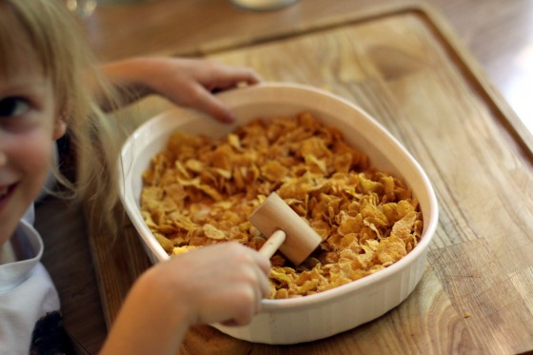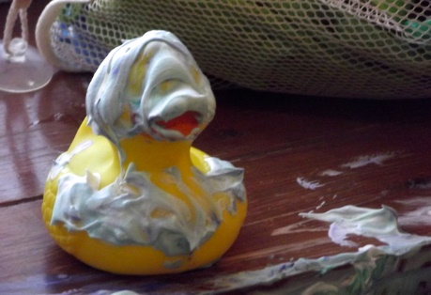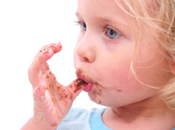

**Contact us**

Visit www.kentcht.nhs.uk/cits or contact our speech and language therapists at the Children's Integrated Therapy and Equipment Service if you have any queries or concerns regarding the information in this leaflet.

If you have any concerns about your therapy or home adaptations you are advised to call Therapy One Point (TOP) on 0300 123 2650. TOP is open Monday to Friday, 8.30am to 4.30pm.